IRON CYCLE-
Iron is an essential micronutrient for almost every life form. It is a key component of hemoglobin, important to nitrogen fixation as part of the Nitrogenase enzyme family, and as part of the iron-sulfur core of ferredoxin it facilitates electron transport in chloroplasts, eukaryotic mitochondria, and bacteria. Due to the high reactivity of Fe²⁺ with oxygen and low solubility of Fe³⁺, iron is a limiting nutrient in most regions of the world.

Key Points
- Iron is an important limiting nutrient for plants, which use it to produce chlorophyll. Photosynthesis depends on adequate iron supply. Plants assimilate iron from the soil into their roots.
- Animals consume plants and use the iron to produce hemoglobin, the oxygen transports protein found in red blood cells. When animals die, decomposing bacteria return iron to the soil.
- The marine iron cycle is very similar to the terrestrial iron cycle, except that phytoplankton and cyanobacteria assimilate iron.
- Iron fertilization has been studied as a method for sequestering carbon. Scientists have hoped that by adding iron to the ocean, plankton might be able to sequester the excess CO2 responsible for climate change. However, there is concern about the long term effects of this strategy.

Key Terms
- Haemoglobin: the iron-containing oxygen transport metalloprotein in the red blood cells of all vertebrates.
Iron (Fe) follows a geochemical cycle like many other nutrients. Iron is typically released into the soil or into the ocean through the weathering of rocks or through volcanic eruptions.
The Terrestrial Iron Cycle: In terrestrial ecosystems, plants first absorb iron through their roots from the soil. Iron is required to produce chlorophyll, and plants require sufficient iron to perform photosynthesis. Animals acquire iron when they consume plants, and iron is utilized by vertebrates in hemoglobin, the oxygen-binding protein found in red blood cells. Animals lacking in iron often become anemic and cannot transmit adequate oxygen. Bacteria then release iron back into the soil when they decompose animal tissue.
The Marine Iron Cycle: The oceanic iron cycle is similar to the terrestrial iron cycle, except that the primary producers that absorb iron are typically phytoplankton or cyanobacteria. Iron is then assimilated by consumers when they eat the bacteria or plankton. The role of iron in ocean ecosystems was first discovered when English biologist Joseph Hart noticed “desolate zones,” which are regions that lacked plankton but were rich in nutrients. He hypothesized that iron was the limiting nutrient in these areas. In the past three decades there has been research into using iron fertilization to promote algal growth in the world’s oceans. Scientists hoped that by adding iron to ocean ecosystems, plants might grown and sequester atmospheric CO2. Iron fertilization was thought to be a possible method for removing the excess CO2 responsible for climate change. Thus far, the results of iron fertilization experiments have been mixed, and there is concern among scientists about the possible consequences of tampering nutrient cycles.

Iron Cycles Too.
Iron (Fe) atoms also cycle through the ecosystems of the world. Although there is cross-over, there is a difference between the cycling on land and in the water. The differences are based on how the producers get their iron in the first place. Iron must be in the seawater for sea plants and phytoplankton to use it. A great deal of iron is in the soil or other organisms for the land creatures to consume.

Start With The Plants
As with many cycles, the iron cycle starts with plants. Plants on land get their iron from the soil. Iron is an abundant element on the planet so you will find it in many rocks and biomes. Good soils are often rich in iron compounds. Iron also gets into the soil when organisms die and sometimes when they poop. All organisms use iron in some form. Iron is an essential nutrient. Many enzymes require iron to work. So plants get iron out of the soil and into their tissues.

Then The Animals
Animals need plants to get iron into their systems. You might get iron by eating beets, carrots, celery, or potatoes. If you eat meat you will get a lot of iron from eating the flesh of other animals. The main point is that animals need to eat substances that have already absorbed iron. We can't get our iron from the soil or by eating rocks. Humans use iron in their hemoglobin. Hemoglobin is the compound that carries oxygen through the body. A lack of iron in the diet results in a disease called anemia.
Once the iron is captured from the environment it is free to circulate between plants and animals. Scientists have even tried to stimulate the growth of plants in the ocean by adding iron to the water. The phytoplankton grew more with the extra iron, but it was only a temporary effect. Iron usually makes its way into the ocean from runoff or from the dust circling the earth. When a volcano erupts, large amounts of dust are sent into the atmosphere. That iron rich dust lands on the soil and in the ocean.
Ferrous iron-oxidizing phototrophic bacteria from different phylogenetic groups are-Purple sulfur bacteria.,e.g., Thiodictyon sp. in Freshwater marsh, Purple non-sulfur bacteria., e.g., Rhodobacter fe rrooxidans , Rhodomicrobium vannielii, Rhodopseudomonas palustris Rhodovulum iodosum ..- Rhodovulum robiginosum.
And Green bacteria., e.g., Chlorobium ferrooxidans.

THE BIOGEOCHEMICAL CYCLE OF IRON ON EARTH-
Biogeochemical cycles describe pathways by which chemical elements move through both biotic (the biosphere) and abiotic compartments (the atmosphere, hydrosphere, and lithosphere) on Earth. Along with energy flows, biogeochemical cycles establish the relations among ecosystem compartments at local, regional and global scales. In these systems of inputs, outputs, sources and sinks, elements are moved from one part of an ecosystem (e.g., ocean, soil, atmosphere) where the element may temporarily accumulate to another, back and forth among organisms, and from living organisms to the abiotic environment and back again. In other words, chemical elements are cycled and reused within and among Earth's various compartments over and over again.
The biogeochemical cycles proceed through biological, geological and chemical interactions along hydrological, gaseous, and mineral "trade routes." Among the most ecologically important and well known are the element cycles of carbon (C), nitrogen (N), oxygen (O), phosphorus (P), and sulfur (S), as well as the water (H₂O) cycle. One biogeochemical cycle that is often overlooked, however, is Earth's iron (Fe) cycle (Figure 1).
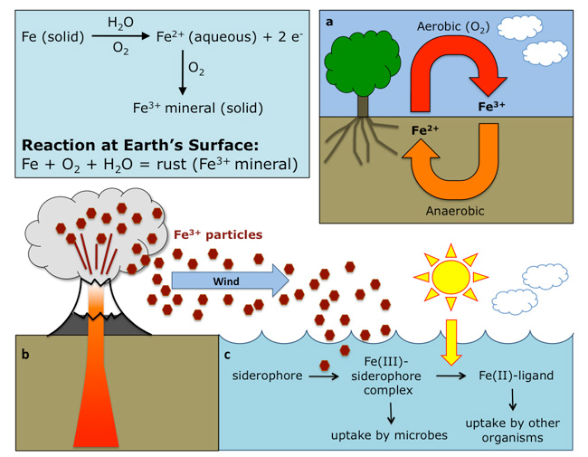
Figure 1: The biogeochemical cycle of iron on Earth
Natural processes, anthropogenic activities, and microbial communities affect the iron cycle. In nature, both iron oxidative and reductive reactions (a) depend on environmental conditions and microbial activities. Iron is oxidized into Fe³⁺ under aerobic conditions, or by microbes under acidic pH, and it is reduced to Fe²⁺ under anaerobic conditions. Iron can be transported to the ocean (b) as dust or volcanic ash. Coarse particles will sink rapidly, while smaller (colloidal) particles will travel further and stay in the surface ocean, increasing the amount of bioavailable iron. (c) are chelating agents secreted by microorganisms under low iron stress. They scavenge Fe from the environment and form Fe(III)-siderophore complexes, making the otherwise insoluble iron, available for bacterial uptake. The complex can be photolysed, resulting in the reduction of Fe(II) and a ligand, thus becoming available for planktonic communities

